Before adding Trailers into inventory, you must have the signed packing slip, the invoice from the vendor and the invoice from the freight. Divide the freight by the # of trailers to get your landed cost and use that landed cost to enter the trailers into inventory.
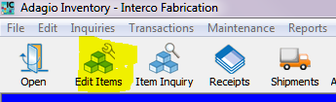

In Adagio Inventory Control, select Edit Items on the top left corner of your screen.
>new
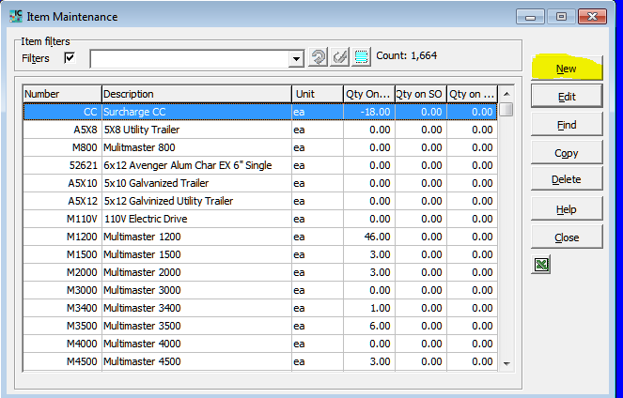
Look in the Item list for an example of the format that is used for that Vendor.
For example Stealth Trailers are STE + the last 5 digits of the serial #. So STE02934 would be the Item# for a stealth trailer with the serial 56UBE1218KB002934.
It is important to keep that format so that if someone is looking for an Item and all they have is the serial # they will know exactly what the Item# should be.

Under the item tab fill in
- Item #
- Description
- Category code (should be the Vendor)
- Account Set (Interco Trailers are Account Set “Interco Trailers” and other trailers are Account Set “Purchased Trailers”.
- Stocking unit(always going to be EA)
- Price (Retail Price)
- (Landed) cost
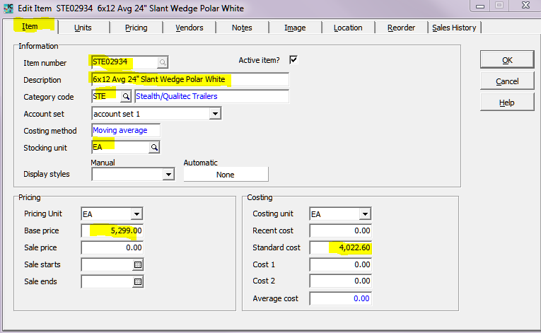
Then go to the Location tab and make sure you are adding this trailer to the right location.
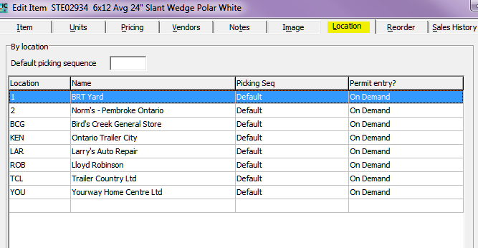
Once you’ve double checked your information you can close this and now you have your new Item.

